

Press Release Nov 2020

The LANDA “Just In Time” Collection

LANDA was born out of a passion for quality, timeless bags with luxurious details. That passion continues to inspire us to this day.

Our founder Silvana Landa grew up in Argentina watching her Italian grandfather work with leather in his cobbler’s workshop. Through those young eyes, she appreciated his craft, his attention to detail and so began her love of working with leather.

Amidst the rich earthy aroma of leather, along with the hum of the sewing machine, Silvana helped her grandfather Miguel with the hand-stitching and finishing processes. Those young hands created texture, form and function in perfect harmony.

In 2018 Silvana realized her dream and created Landa, an Irish brand with global appeal. As a busy, working mother on the go, Silvana designed this range of bags, crafted with practicality in mind so that they work no matter what the demand. Functionality, design and quality are the DNA of Landa

Landa celebrates traditional manufacturing expertise and works with small factories that handcraft each item to bring to life the most exquisite handbags. The materials are carefully sourced following the brand’s commitment to conscious and ethical production. Landa works with suppliers and partners who have a similar ethos.

As ever, we keep our customers’ needs at the forefront of our design process, with bags that really work for the lives we lead. This season, we appreciate the desire for a more mobile and clutter free approach to living and have created pieces that do all that without compromising on luxurious details.

**WHAT’S NEW**

1. TECA

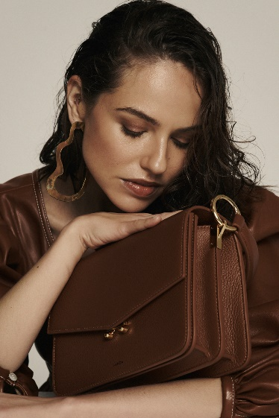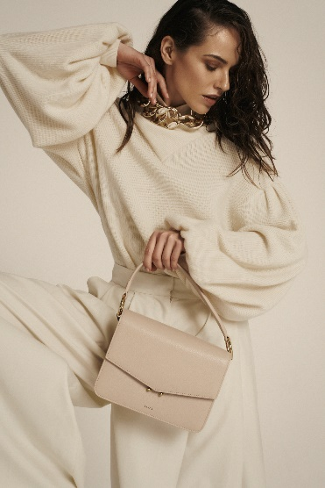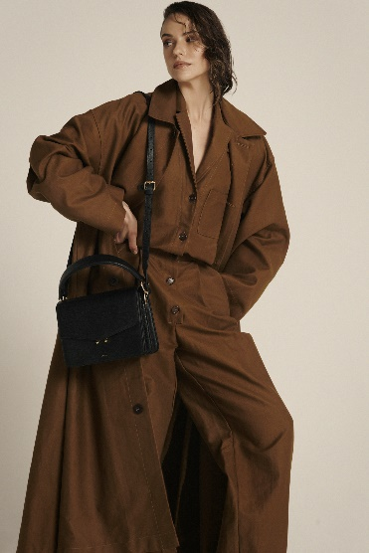

This is LANDA’s latest crossbody bag featuring a new, elevated design. It is crafted from full grain pebbled leather, one of our signature materials, that's known for its durability and beautiful aesthetic.

This structured stylish bag opens up to reveal several compartments to help you to organize your belongings. The central compartment has a zipper closure for extra security featuring the signature long LANDA zipper puller that is a pleasure to use. The bag also features a key clip.

This beautiful bag has an adjustable shoulder strap as well as a short handle to be carried by hand. Both strap and handle are removable and adaptable to your day’s needs.

The divided accordion silhouette is roomy enough to hold your daily essentials and there's an external slip pocket in the back of the bag for easy access to your phone or face mask.

This bag is fully lined in a gorgeous beige suede that is beautiful to see and touch. TECA is finished with luxurious eco-friendly edge painting and gold tone hardware. TECA is the name we gave to this bag. TECA (Teak wood) is a tropical, very sought after, hardwood tree with beautiful fragrant white flowers. All our products are named after trees showing our appreciation and love for nature. (RRP €365)

1. TILIA:

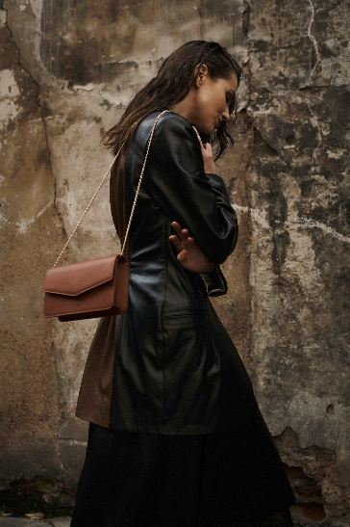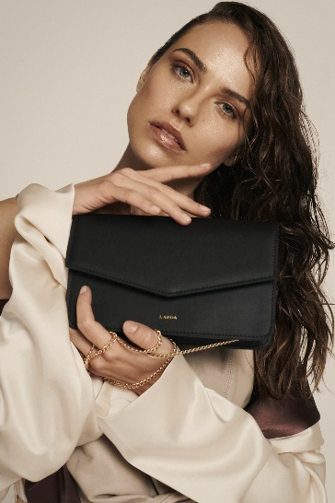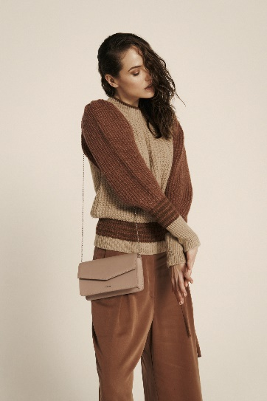

With minimalism in mind, our new TILIA bag is a cute and stylish Wallet on Chain. The built-in wallet offers easy access to your cards, once again, focusing on the value of carrying less and therefore, making everyday life easier.

This clever and stylish little bag is made in beautiful full grain smooth leather. The sleek envelope shape opens to a wallet-like interior complete with 8 card slots and an extra slip pocket to secure small items.

The fine chain is super versatile and offers 3 ways to wear it. Crossbody for the gal on the go, hide chain and carry as a clutch for the evening or double it inside and carry it on your shoulder for a more sophisticated evening look.

This bag is fully lined in a gorgeous beige suede that is beautiful to see and touch. TECA is finished with luxurious eco-friendly edge painting and gold tone hardware.

TILIA is the Spanish for Linden tree. All our products are named after trees showing our appreciation and love for nature. Tilia is a very much-loved tree in Argentina known for its beneficial properties. (RRP €185)

1. TIPA:

LANDA’s first VEGAN leather addition.

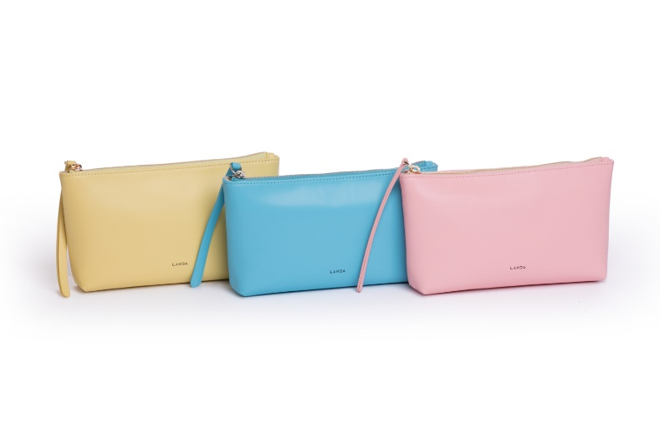

Our love of colour is expressed in full force in the new limited-edition vegan pouches with a kaleidoscope of beautiful yellows, pinks and blues.

These pouches were made using a high-quality VEGAN material in gorgeous uplifting colours. This microfiber is lightweight, exceptionally durable and water repellent. The interior is lined with a beige suede like microfiber and features the LANDA signature long zipper puller that is a pleasure to use. The pouch is finished with our luxurious eco-friendly edge painting. This pouch is finished in gold tone hardware (or silver in the blue version). This product is the first of our new VEGAN range, and is designed to keep your smallest necessities close at hand, allowing you to easily transfer them from one handbag to another. Or simply, have it as a make-up bag or handy for when you nip out to the shops or bring your dog for a walk. TIPA is the name we gave to this pouch. TIPA is a beautiful tree, original to South America and Argentina, where our founder is from. All our products are named after trees showing our appreciation and love for nature. (RRP €55)

We are delighted with this season’s collection of functional, gorgeous looking bags that are perfect for the modern woman on the go.

All available at [www.landabags.com](http://www.landabags.com)

All images (DropBox links) on body of email.

For more information, please contact:

Silvana Landa McAdam [silvana@landabags.com](mailto:silvana@landabags.com) 0873902362