Expression of Interest Application Form

Innovation and Entrepreneurial
Practices for SME’s Project

Instructions

- Before completing this document, please read the Call for EOIs guidelines, which provide details on the ‘Innovation and Entrepreneurial Practices for SMEs’ funding opportunity.
- Please ensure all questions are answered. Please type your answers under each question and expand each section as required.
- Depending on how many Lots of funding you are applying for, you will be required to complete some of the questions for each specific lot.
- Please observe the word limit per question. There is no requirement to use the full word count.

About your Network/Scheme:

Network/Scheme Name: | ISME Skillnet / ‘’The ISME STAGES Programme’’
Year Established: | 2000
Industry: | National SME business representative organisation

What Lot are you applying for:

 | Please indicate with an X

LOT 1: Design and Delivery of Pilot: Regional Partner Management and Regional Clinics
LOT 2: Development and/or customisation and pilot delivery of Existing Innovation and/or Entrepreneurial Upskilling Programmes | x

LOT 3: Delivery of additional capacity on Existing Innovation and/or Entrepreneurial Upskilling Programmes

KPIs
Projections for each Lot (where applicable). Where you are offering multiple Lots, please provide the numbers for each

 | Lot 1 | Lot 2 | Lot 3
Number of companies |  | 70
Number of participants |  | 130
Number of training days |  | 650

Budget summary to deliver this programme
Budget Line | Lot 1 | Lot 2 | Lot 3 | Total budget in EUR | Budget line as % of the total budget
Total management costs (max 25% of the budget) |  | 52,000 |  | 52,000 | 25%
Delivery costs (training costs) |  | 135,000 |  | 135,000 | 65%
Total |  | 187,000 |  | 187,000 | 90%*
*Remaining 9% is for a marketing budget – website page development, programme launch events, social media and advertising campaigns.

- Alignment

Relevance of the proposed programme interventions to the funding priorities, industry needs and objectives of the programme.

  - How will you align with the objectives of this scheme in supporting the embedding of innovation and entrepreneurial practices in SMEs at a regional and industrial level?

It is imperative that ISME provides a model to its members to equip a business owner with the basic knowledge of running their business efficiently, safely and legally. Many of our members have great businesses but no formal training in HR, payroll, tax, VAT and managing people. This has an impact on the business’s productivity. To give them a solid understanding in key areas of operations means they will run their businesses better, legally and in compliance with revenue and the WRC.

A solid platform of operations will allow a business to spend time on other crucial areas such as growth opportunities, staying competitive, efficiencies and cost reduction. Innovation practices will lead to improved customer experiences which builds loyalty. Being seen as a forward-thinking business builds trust and keeps customers coming back. An attractive company will also attract the right talent important in today’s tight recruitment market.
Having conducted research on the Irish SME sector, we have identified characteristics in SMEs that need addressing. These include dependence on the domestic market; export performance; export characteristics; technical capabilities such as financial management, IT capability, marketing capability, innovation; staffing levels and qualifications; risk identification and management; research capability; strategic planning; and the ability to engage with digitisation and the sustainable economy.

We have developed eight strategic themes to address these SME requirements:
- Survive / Rescue – early intervention to avoid SCARP.
- Export – creating customers for Enterprise Ireland.
- Finance and Treasury
- Technology – new tech absorption / Digital and AI
- Productivity
- Managing People / HR
- Scaling and Exit Strategies
- Decarbonisation / Green Strategies.

The new funding strand will allow the network to provide a business owner and their key staff basic core business skills, an entrepreneurial mindset, and the ability to address innovation in a professional and confident manner.
The network’s proposed S.T.A.G.E.S. Programme would underpin the NCPC / Enterprise Ireland’s Drivers of Productivity Model (Table 1). Scaling, exporting, innovation, new technology adoption and the other important activities that drive productivity are all featured here. With initial mentoring engagements supported by ISME would give a business the tools and knowledge to make their next step towards growth.

- Survive: This is focussed on early-stage and start-up businesses and addresses how to get a business off the ground, or out of financial trouble using the EWEMA¹ framework.
- Thrive: This theme addresses those businesses that have survived start-up and are considering basic strategies to develop their product or service in a dynamic workplace.
- Accelerate: Using basic strategy tools to understand and exploit the micro-external and macro-external environment of the company.
- Grow: The development of organic growth via market penetration, market development, product development and diversification strategies.
- Export: A key element for companies with ambition to become EI clients is the ability to export. This element focusses on growth by export.
- Scale: This final stage of enterprise growth goes beyond the organic and considers broader strategic options such as blue-ocean strategies, exit, merger, acquisition, partnership, alliance, joint venture, and the effective evaluation of strategic options.
Table 1:
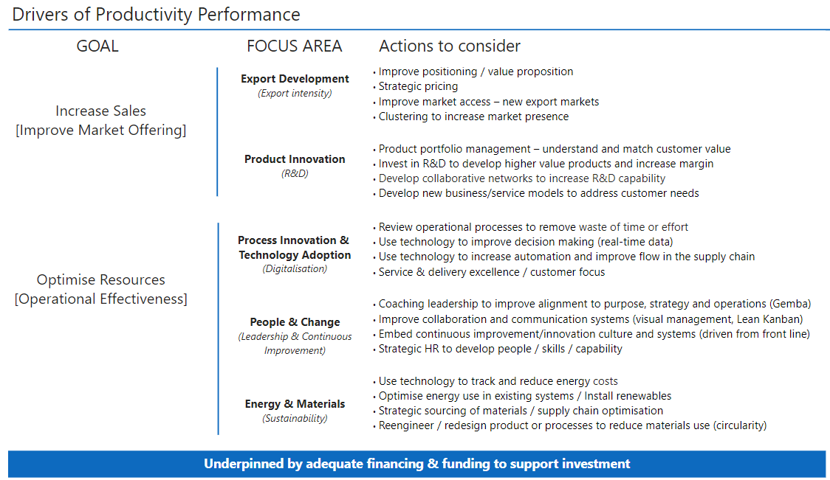
We will be co-hosting a joint event with Enterprise Ireland in September 2025. ISME’s role in this instance is to convert ISME members into Enterprise Ireland customers.

  - Please outline how you will align with the Programme Parameters under Lot 1, Lot 2 and Lot 3 listed in the Call for Expressions of Interest guidelines that you are applying for.

LOT 2: Development and/or customization and pilot delivery of Existing Innovation and/or Entrepreneurial Upskilling Programmes
During 2021-2023 we delivered a successful mentoring and coaching initiative to our members. We assisted 160 companies do something innovative, introducing improvements and efficiencies (testimonials in the appendices). The engagements supported included digital adoption, cash management / improved financial arrangements, scaling and exit, supplier contract renegotiation due to the sudden rise in business costs, and overviews of supply chain strategies (Climate / Green and overall efficiency).

One of our previous mentoring alumni recently conducted a successful exit to an acquiring Irish VC entity which intends to scale that business.

This agile model for learning interventions meant the network addressed ever changing economic trends and business issues in a timely way.

To further improve this offering and align with new business trends in 2025 the network will need to:

- Further recruit diverse and experienced mentors / coaches.
- Tailor the programme to current business needs and differing industry sector requirements.
- Allow a company to avail of more than one engagement for a more impactful outcome (EG one digital adoption and one financial management).
- Run in-company innovation workshops for wider team collaboration.
- Run in-company entrepreneurial workshops to create growth mindsets.
- Document evaluations and case studies to show how mentoring led to real innovation / entrepreneurial outcomes.

2. Capacity

Capacity (human, technical, organisational) of the Network to deliver proposed interventions.

2.1 How will you ensure successful delivery of the proposed programme(s)/project(s) before the end of December 2025? Please attach a high-level Project Plan with your application with details, as appropriate, on cohort sizes and start dates.

All funding streams
Demonstrated Demand & Capacity:
- Growth appetite: Our job is to turn our members into Enterprise Ireland clients. Our mentoring initiative was an excellent vehicle to support our members. We have an extensive expressions of interest list of companies wishing to re-engage on our proposed STAGES Programme.
- Management: There is material underperformance at director level within SMEs versus the large multinationals. As our members have an ambition to expand, they have expressed interest in addressing their leadership / management issues.
- Sector representation: There is increased demand from the industry sector associations we support – Health Stores Ireland, LIA, Brokers Ireland, Pharmacies, Small Vets, Fine Jewellers, IPICS (Supply Chain Association) and The Travel Centres group. These are national representative associations providing a far-reaching audience around Ireland.
- Active engagement: The network has engaged 210 people in their training programmes for small business from these industry associations during 2024, 180 of them were owner managers, or managers in the business. These are a good target market for the STAGES Programme with many of them attending 2 or more of our training events during the year. They understand the value of continuous learning.
  - With 10,500 members, ISME has a large SME community database of contacts.
  - The ISME Skillnet has an opt-in/opt-out training database of 9,600 contacts.
  - 160 companies engaged in our mentoring programme 2021-23. Many have requested a continuation.
  - ISME’s marketing team is ready to assist the network with programme launch events, promotional activities and to deliver an advertising campaign, both traditional and digital campaigns (see delivery team section).
  - The ISME National Council is made up of 27 nationally based business owners from all industry sectors, many from large business associations with many member companies themselves. They have proven invaluable in promoting the network’s training schedule and upskilling initiatives.

High level project plan:

Planning, design adjustments: Weeks 1-4
Promotion of EOIs and member company recruitment: Weeks 5-6
Onboarding / x 2 Launch events: Weeks 7-9
Programme Delivery: Weeks 10-24

We are planning a joint event with Enterprise Ireland (EI) to facilitate the launch of this programme. An important responsibility of ISME is to convert our members into EI customers. We anticipate a date in early September for this event.

Programme monitoring will take place throughout the programme.
Feedback will be sought on completion of each event / engagement sessions.

Cohort sizes will vary but mostly 1:1 / 1:2 and 1:3
We will engage a minimum of 70 business and 130 business owners / employees in 2025.

2.2 Please describe existing and/or planned resources and capacity within your Network to deliver the programmes(s)/project(s)? Detail any apportionment across other activities.

All funding streams
Innovation / Entrepreneurial Scheme delivery team percentage of effort:

Adam Weatherley – Network Manager (FTE) – 80% effort on Innovation initiative
Ruth Connolly – L&D Operations / Executive (part-time 60%) - 30% on Innovation initiative
Damien Heffernan – ISME Partnership Manager / Events Management (FTE) – 20% Marketing / Events Management effort for Innovation scheme.
Gopika Murali – ISME Marketing Executive (FTE) – 20% Marketing effort for the Innovation scheme.
Rachel Barrett – L&D Project Administrator – Part-time 60% - 20% on Innovation initiative.

TNP NTF / TNP ESF+ / SkillsConnect:
The remaining effort will be focused on the other funding strands with Ruth and Rachel taking on most of the delivery.

Adam Weatherley - 20% - TNP NTF / ESF+ / SkillsConnect
Ruth Connolly – 70% - TNP NTF / ESF+ / SkillsConnect
Rachel Barrett – 80% - TNP NTF / ESF+ / SkillsConnect

Adam will focus on the delivery of the Innovation and Entrepreneurial Scheme due to the tight delivery window and the importance for its success.

- Quality

Evidence of programme quality including learning outcomes and value for money

3.1 Briefly detail the overall learning outcomes and award level (if any) expected from the proposed training programme(s), under the following headings (applicable to Lot 2 and Lot 3):

LOT 2: Development and/or customisation and pilot delivery of Existing Innovation and/or Entrepreneurial Upskilling Programmes. Please copy-and-paste additional tables per each programme as required.

Programme Title | ISME S.T.A.G.E.S. Model (Survive, Thrive, Accelerate, Grow, Export, Scale)
Learning Outcomes for the trainee | Creative Problem-Solving Abilities  Familiarity with Innovation Frameworks  Practical Skills in Idea Generation and Evaluation  Improved team collaboration  Understand basic project planning, resource management, and tracking progress.  Growth mindset development
Outcomes for the company | A business will be more adaptable, competitive, and growth oriented.  Development of a culture where continuous improvement and creativity are valued.  Understanding Innovation Processes  Practical Implementation Planning  Future proofed business  A resilient business and agile to economic trends
Course duration | A series of 6-hour engagements chosen from the eight themes described in 1.1 of the document.
Award level (if any) | There is no award level intended for this programme. However, it is ultimately our objective that the core elements of the S.T.A.G.E.S. programme would form the basis of a level 6 diploma in basic business practice.
Description of cohort (e.g. is this 1:1, is there a minimum cohort size for peer learning, etc.) | 1:1 / 1:2 / 1:3  6-hours available per individual / per engagement
Brief description of programme | The key aims of the proposed programme would be to achieve several macro-objectives. These include:  - Creating an SME sector that is dynamic and innovative.  - Broadening the enterprise and export base to ensure that the economy is resilient, diversified, and adaptable.  - Assisting indigenous businesses to quickly adopt the green economy.  - Supporting the internationalisation and market diversification of Irish enterprise to make the economy more resilient to external market shocks, (Brexit, COVID19, economic downturn).  - Grow the capacity of local firms to absorb and implement new technologies.  - Improve management quality and training in smaller enterprises to foster innovation to evolve into new products, new markets and new sectors.
Alignment to Innovation & Entrepreneurial practices topics | To assist businesses with their understanding of the fundamental areas of business to ensure growth and competitiveness:  - Business and commercial law  - The tax system  - Employment law and compliance with safety, health and welfare at work legislation  - Digitisation, technology absorption and software packages  - Adaptation to the green and circular economy  - Marketing skills, market research and procurement / tendering  - Financial management and treasury skills  - Research and Development capability  - Leadership and staff development  - The export of goods and services  - Intergenerational business transfer, business listing and business exit

3.2 How will the programme(s) deliver strong value for money to your businesses and the wider industry? (please include cost per trainee/company)

All funding streams

Cost per engagement is €1,000. A business can participate in one or two engagements at this pilot phase. Each engagement comprises of 6-hours of mentoring from an accredited business coach / mentor with either sector or domain expertise.

Value to the network’s member companies:

Value Mechanism | Business Benefit | Industry Benefits
Cost Efficiency | Lower operational costs | Shared best practices
Competitive Advantage | Increased market share | Industry-wide innovation
Scalability | Faster internal adoption | Sector-wide standards
Risk Reduction | Reduced failure rates | Lower innovation risk
Long-Term Savings | Sustainable cost reductions | Regulatory compliance
Talent Retention | Improved workforce quality | Higher industry skill base

The network’s S.T.A.G.E.S. Programme is designed to deliver value for money by cutting costs, reducing risks, opening new revenue opportunities, and boost a member company’s business performance.

- Impact and Wider Contribution

Potential impact on participants, businesses, industry and wider talent development agenda.

4.1 What is the expected impact of the proposed programme(s)/project(s) on the participating trainees and businesses and how will this impact be measured? Please refer to the Programme Requirements under each Lot in the Guidelines for list of KPI examples.

LOT 2: Development and/or customization and pilot delivery of existing Innovation and/or Entrepreneurial Upskilling Programmes

The key aims of the programme would be to achieve several macro-objectives. These include:

- Creating an SME sector that is dynamic and innovative.
- Broadening the enterprise and export base to ensure that the economy is resilient, diversified, and adaptable.
- Supporting the internationalisation and market diversification of Irish enterprise to make the economy more resilient to external market shocks, (Brexit, COVID19, economic downturn).
- Grow the capacity of local firms to absorb and implement new technologies.
- Improve management quality and training in smaller enterprises to foster innovation to evolve into new products, new markets and new sectors.
The key skills that would be developed through a mentoring programme would include:

- Business and commercial law
- The tax system
- Employment law and compliance with safety, health and welfare at work legislation
- Digitisation, technology absorption and software packages
- Adaptation to the green and circular economy
- Marketing skills, market research and procurement / tendering
- Financial management and treasury skills
- Research and Development capability
- Leadership and staff development
- The export of goods and services
- Intergenerational business transfer, business listing and business exit

- We have an easy to complete business objective template that sets out what a business wants to achieve by engaging in the Innovation and Entrepreneurial scheme (In the appendices)

- Our certified business mentors and coaches will provide ongoing feedback on progress, attendance, engagement and contribution to workshops from the business.

- The network will seek short-term feedback after the completion of the engagement. We will also seek longer term feedback 4-6 weeks after the event EG Any business impact (revenue, process improvements) from implemented ideas.

- We have incorporated consultant costs to engage a specialist company to assist with an in-depth review and evaluation of the programme.

- A high-level short survey will initially be conducted by the network with participating businesses:

Example Survey Items
- Question | - Scale
- The workshop / engagement met the stated objectives | - Strongly Disagree – Strongly Agree (1–5)
- I felt engaged throughout the engagements | - Strongly Disagree – Strongly Agree (1–5)
- The ideas generated were relevant and actionable | - Strongly Disagree – Strongly Agree (1–5)
- The facilitator managed the engagement effectively | - Strongly Disagree – Strongly Agree (1–5)
- I would recommend this type of workshop / engagement to others | - Yes/No or NPS scale

https://academy.europa.eu/courses/early-warning-mentoring-for-smes

